T.I.M.E. Projects 2023-‐2024
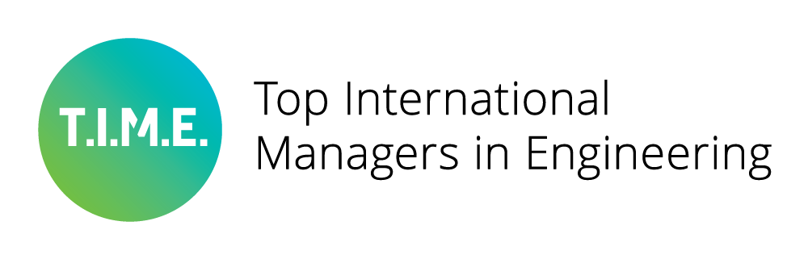
Application Form

Deadline for submission: January 19th, 2024

Please submit the completed form to: gwenaelle.guillerme@time-­‐association.org

Applications must be submitted by e-­‐mail only. You are required to attach a scanned copy of a Letter of Support signed by the Head of your Institution.
Please remember that T.I.M.E. promotes international cooperation and therefore only applications from consortia of at least three T.I.M.E. members in three different countries can be accepted.

You will be notified of the results of the selection after the Advisory Committee meeting on February 2023. Projects run from February 2023 to January 2024.

Title of Project
Acronym (if any)
Details of the Applicant
Name of Institution(s)
Faculty/Department/Office
Contact Person/s and Details
Summary of the Project (max. 2000 characters)
Reason for applying for T.I.M.E. funding (max. 2000 characters)
Expected outputs of the project
Target group/s and expected impact
Sustainability of the programme
Specific deliverables

Total duration of the project
Planned budget
Requested financial support from T.I.M.E.
Other sources of funding
Members of the consortium
1. (Project Leader) 2.
3.
Etc.
Key Staff (Name, Position, E-­‐mail)

Check List

- Attach a signed Letter of Support from the Head of the Applicant Institution ·
Send this form and supporting documents by e-­‐mail only to:
gwenaelle.guillerme@time-­‐association.org

THE DEADLINE FOR THE SUBMISSION OF APPLICATIONS IS JANUARY 19th 2024

